**How to hang\stick things to walls using a drone (complete guide).**

Video guide: <https://www.youtube.com/watch?v=HlP6CXQn-ew>

Using drones to hang\stick things to walls

This guide is based on my experience of using drones to paste images into building walls.

I used a simple DJI MINI 2 drone, but it can be used with most drones.

1. 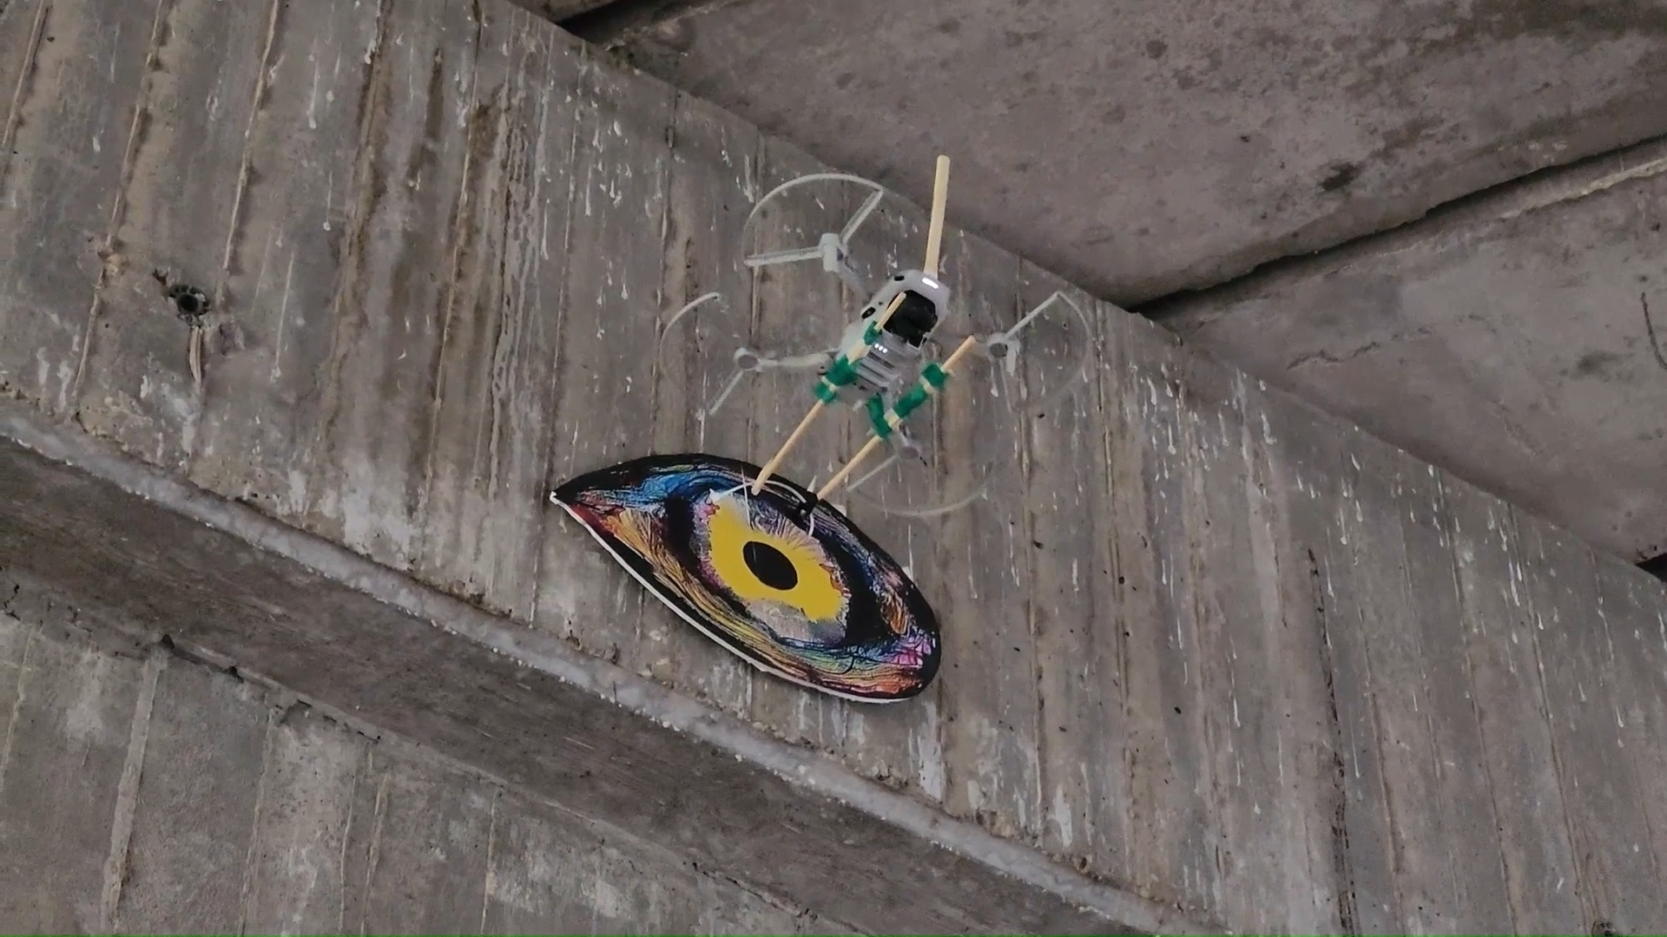

**General Approach**

The full process is shown in the video. It's generally based on pasting the image on a plate, hanging the plate on a hook on the drone, flying it to the wall, and using double side adhesive tape and standard glue to attach the picture to the wall.

The general steps are:

1. Create an L-shaped hook and attach it to the drone.
2. Past the image or LED light to a plate, cover the back of the plate with double side tape and some glue, and add a ring to hang the plate on the drone L-hook.
3. Fly the drone to the wall. Once the back of the plate touches the wall, it will stick.
4. Move the drone downward and release the drone, and that is it.

**Detail instructions**

**Drone preparation**

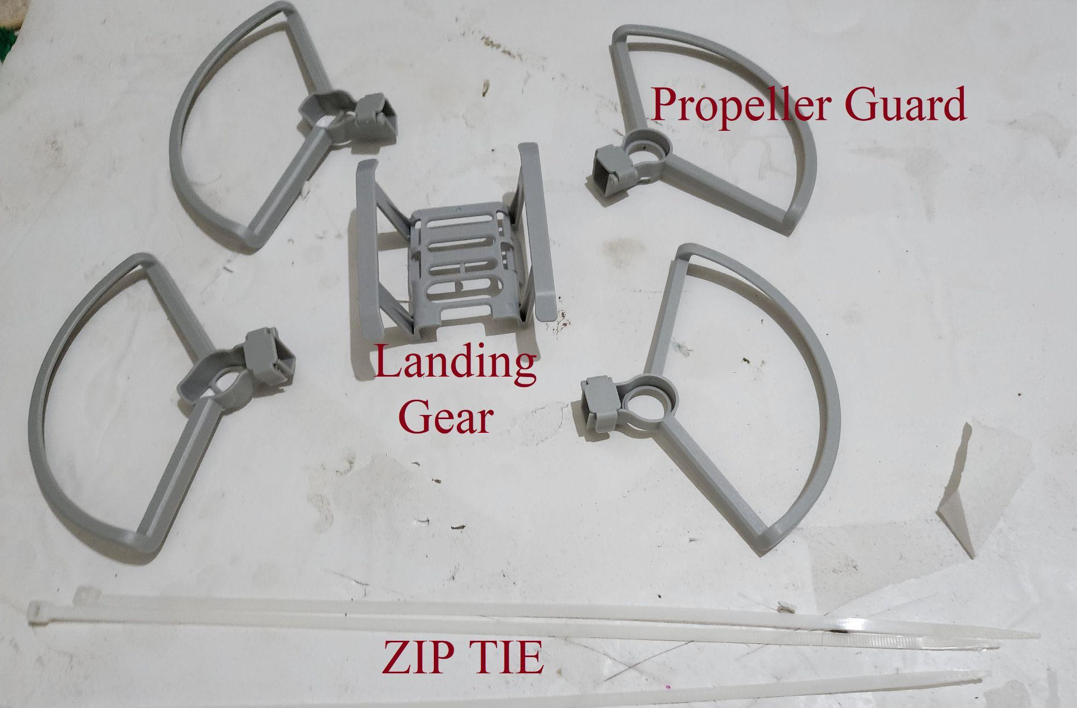

1. If your drone doesn't come with a propellor guard, you must add propellor guards. If the rotor touches the wall, the drone will crash.
2. If your drone doesn't have landing gear, you can buy and add landing gear. Alternatively, you can also attach the L-hook directly to the drone body. The drone landing gear is not built for pulling weights. If you attach the landing gear, it is recommended to use Zip Tie to tie the drone body to the landing gear. Otherwise, the weight of the payload might tear landing gear from the drone.

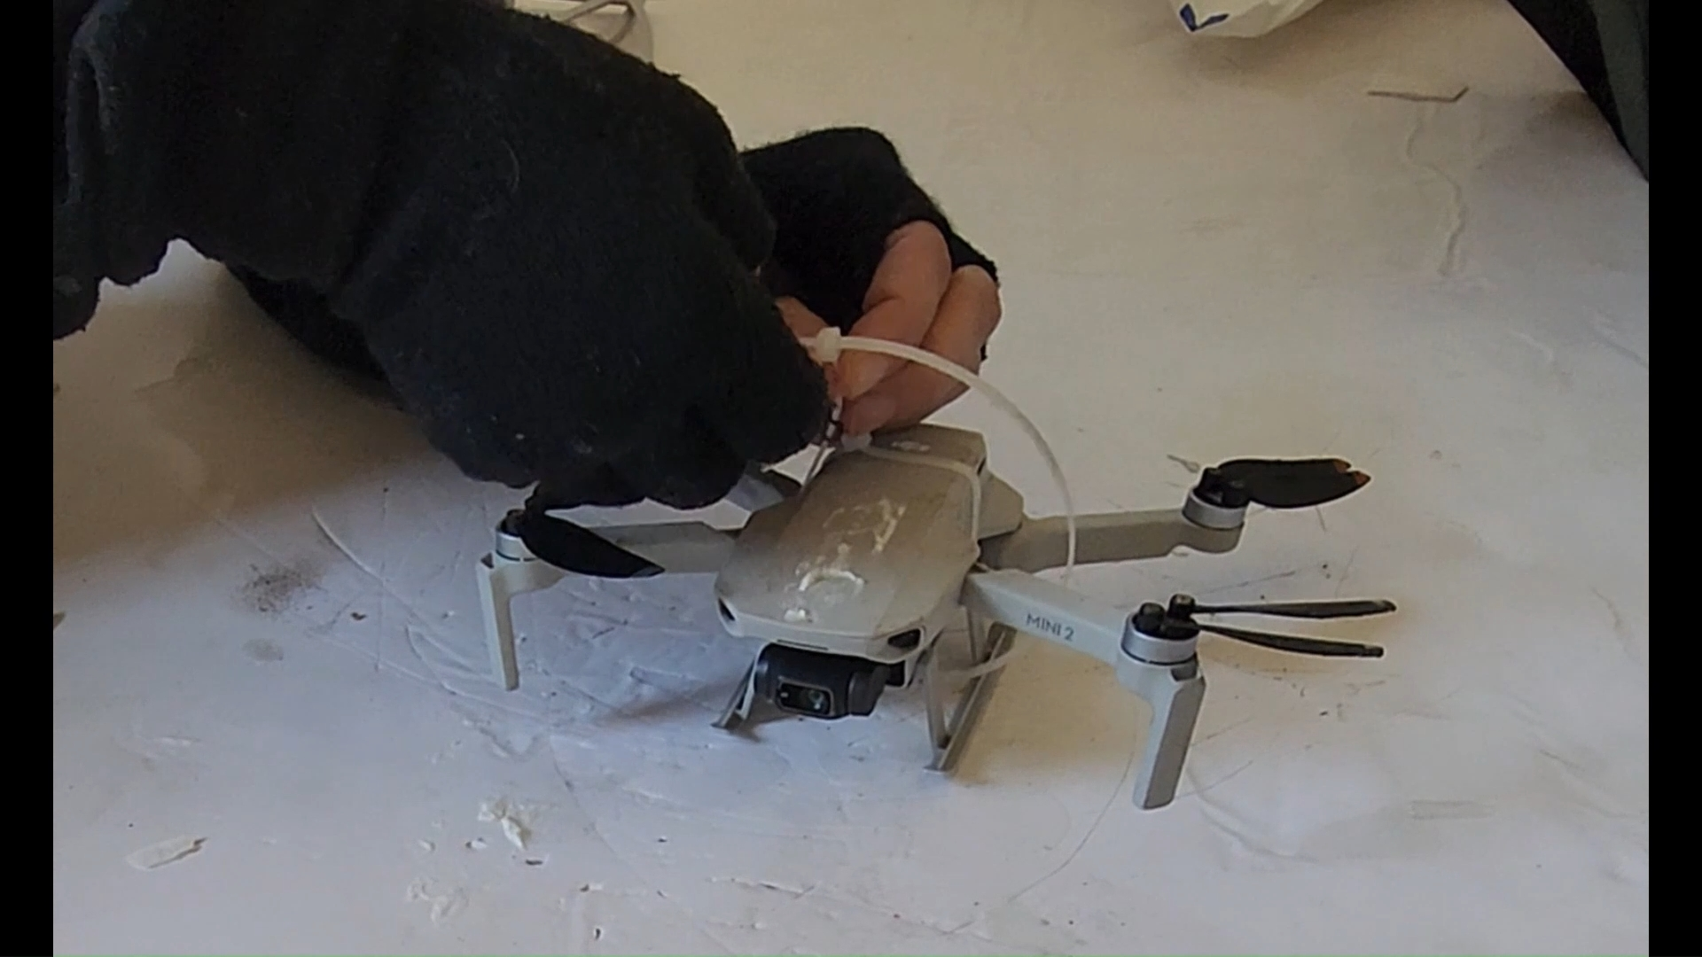

**Hook preparation.**

1. The hook that will use to hang the picture on the drone is an L-shaped stick.
2. Bamboo wooden skewers sticks used for BBQ are great for this. Break the stick about 1-2 cm from the edge to create a 90-degree bend, and use super glue and baking soda to harden the break/bend spot (add superglue and then add the baking soda to harden the glue and fill the cracks. )

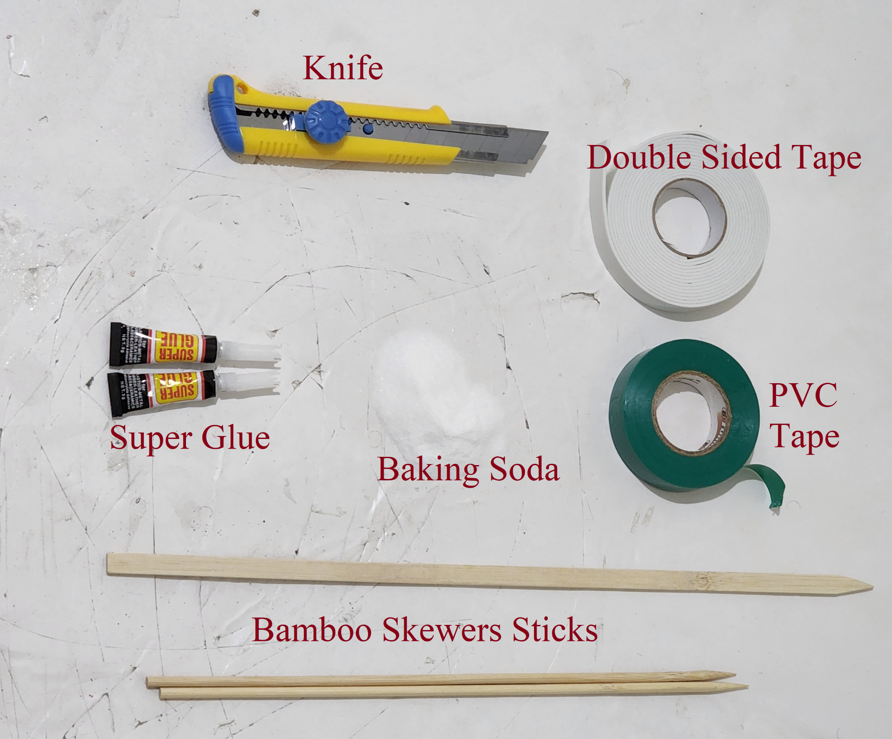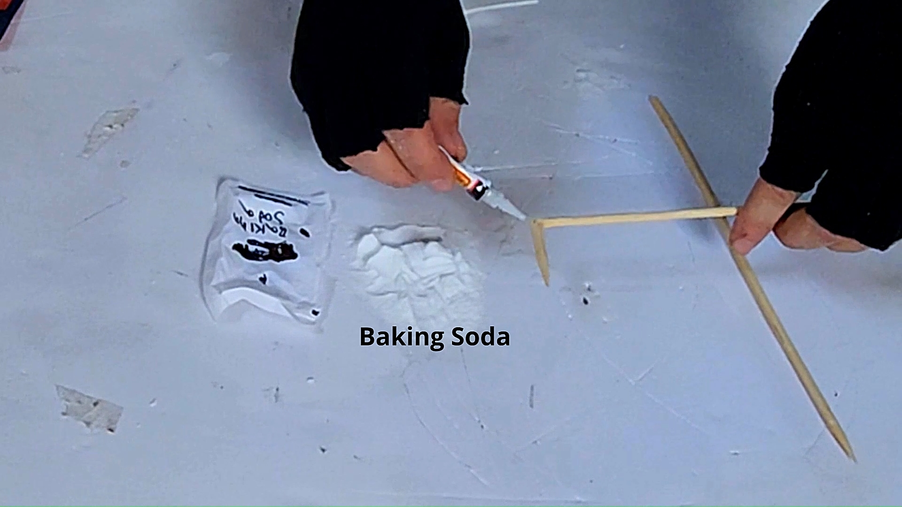

1. Next, we attach the sticks to the drone using double side tape and then wrap it with tape.

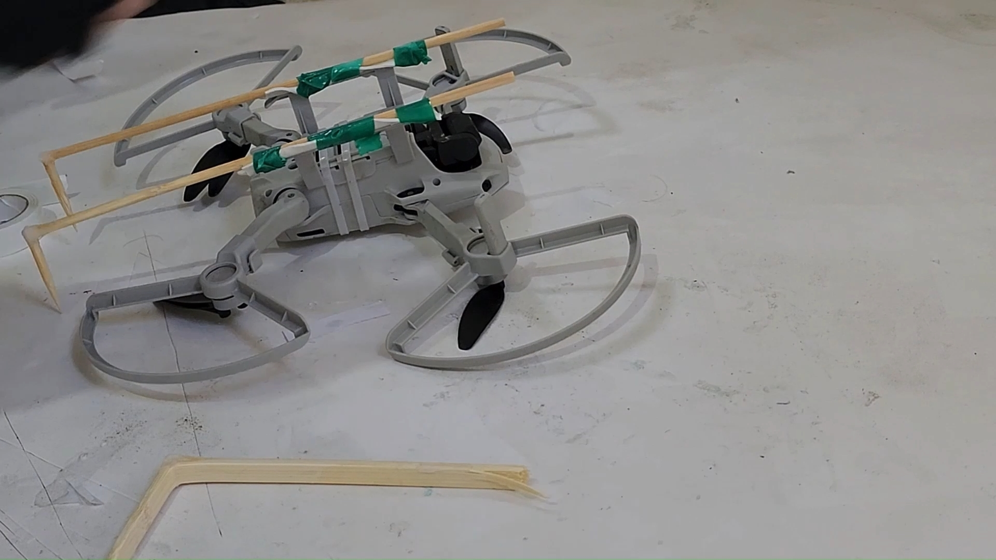

1. When the drone flies next to the wall, there is low pressure between the top of the drone and the wall, which can cause the drone to flip vertically and get sucked into the wall. This can be prevented by adding a vertical stick on top of the drone. Basically, create another L-shaped stick, and attach it to the top of the drone using double side tape and tape or a zip tie.

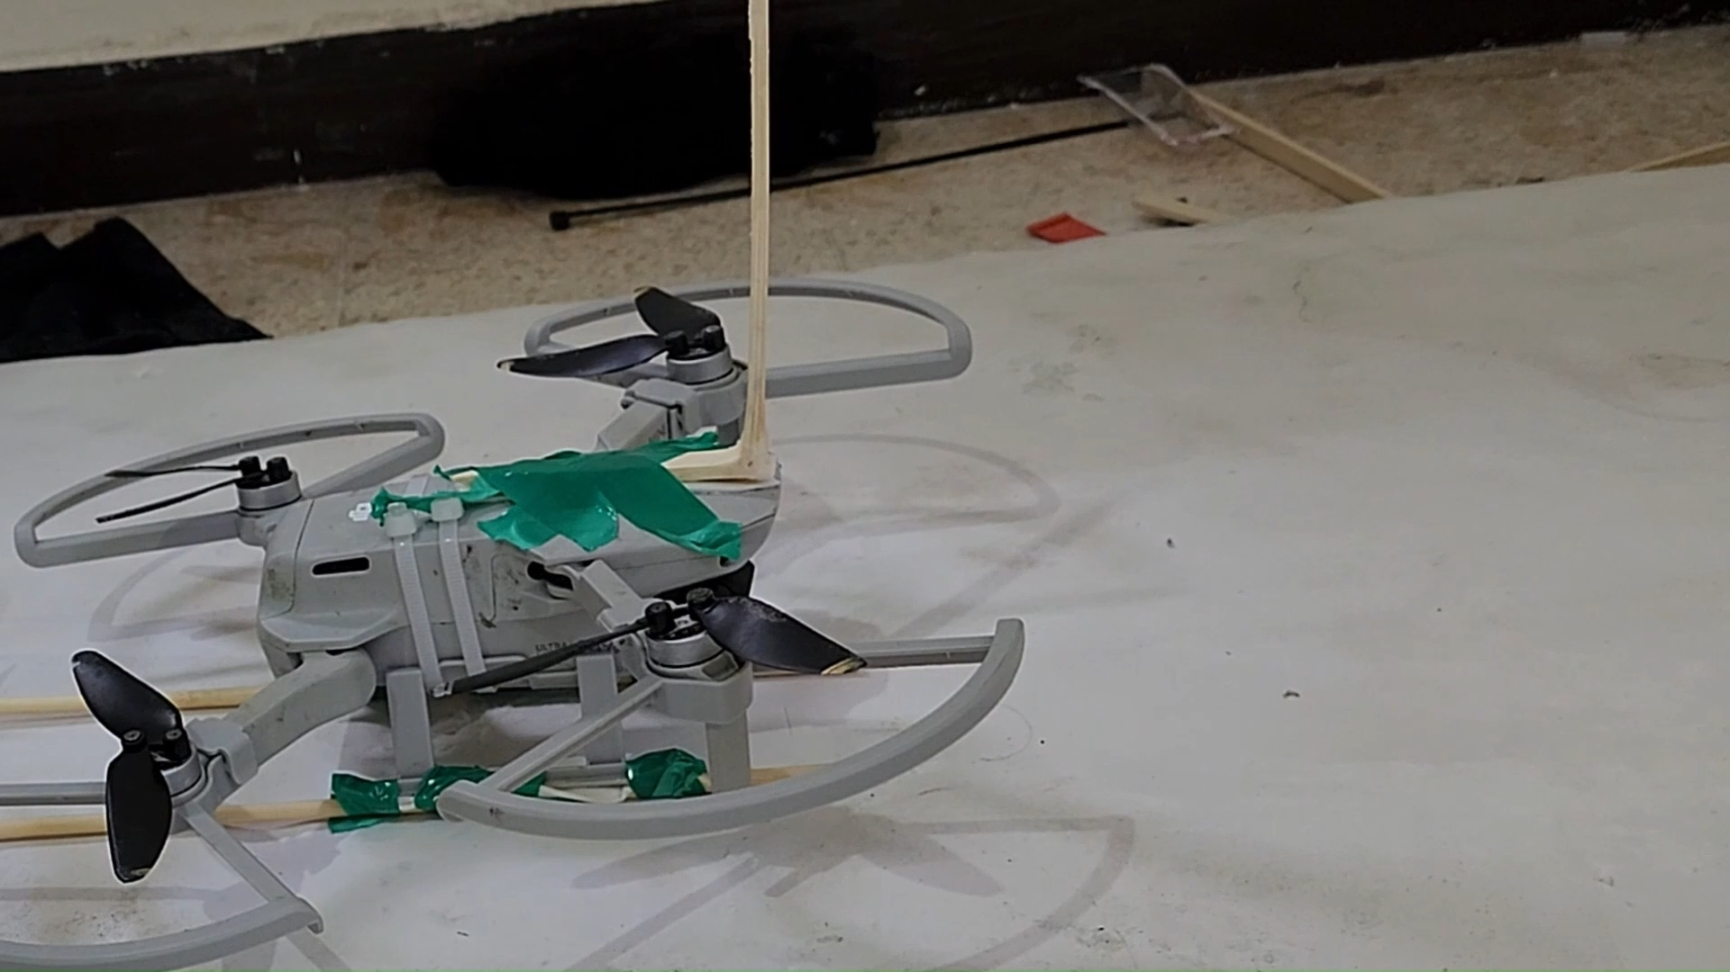

**Preparing the plate:**

Attach the image or LED to a stiff, flat plate. This can be a foam board (Kappa) or a carton board (but have to be flat, lightweight, and stiff). Add double side tape to the back of the plate and add a ring to the front of the plate (where it will be hung on the drone). To create the ring, make two holes in the plate and use a string or a zip tie. The ring has to be on the top of the plate and doesn't have to be too tight (you want the drone to be able to detach).

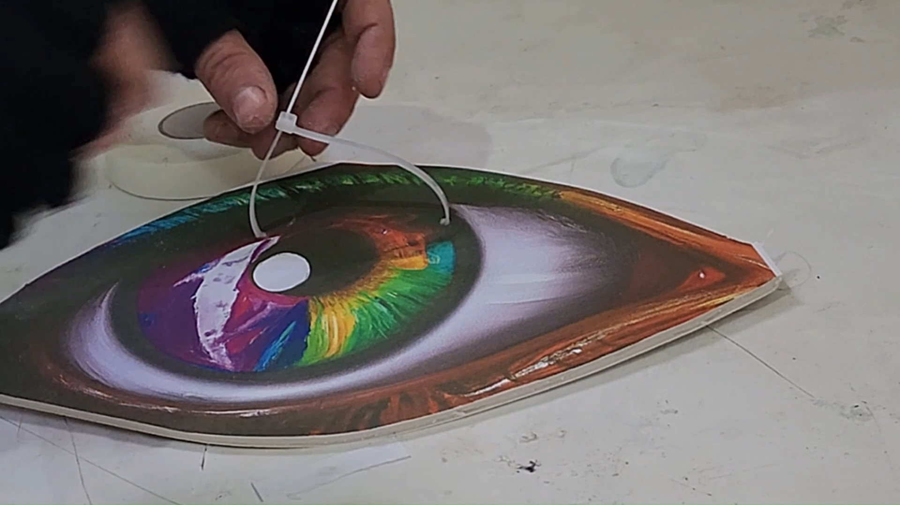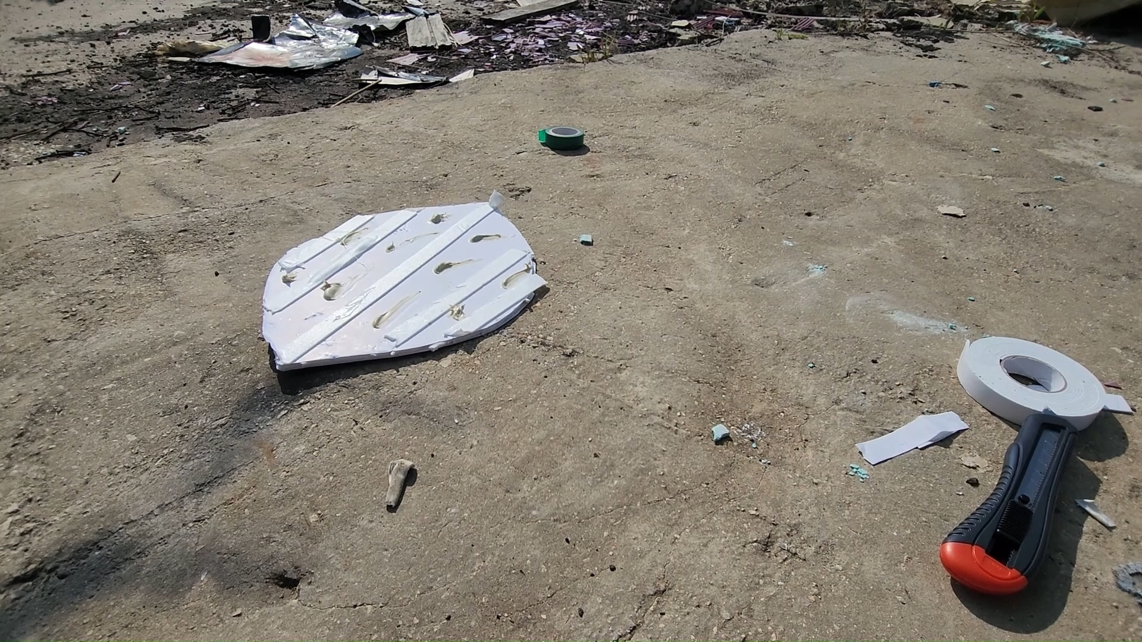

**Flying and pasting with the drone**,

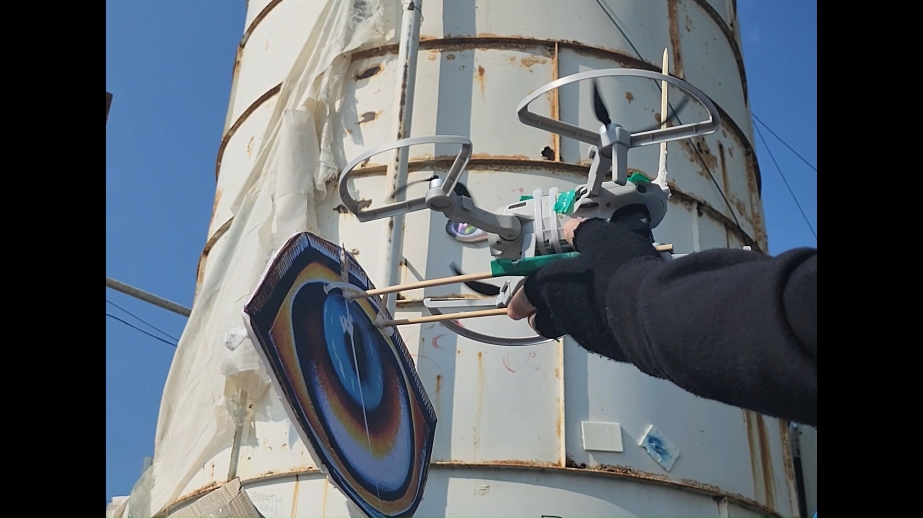

1. When you are ready to fly. Uncover the double tape on the backside of the plate. You can add more permanent adhesives, like superglue, contact glue, or Rhino adhesive. This will make the board attach to the wall more permanently (while the double-sided tape sticks immediately when pressure applies, it is usually less durable).
2. Hang the plate on the drone using the plate ring and drone hook.
3. Lifthof is tricky. The drone is the least stable at take-off because of the extra weight and might flip over. I recommend Holding the drone from below. Pushing the engine to full power and only then releasing. This can prevent the drone from flipping. It is also best to have some space in front of the drone. The liftoff stage is when the drone is most unstable and might drift. Alternatively, you can lift the drone without the payload and hang the payload with the drone already in the air.
4. Once the drone is lifted, it is usually stable, and it is best to fly it slowly with no sudden acceleration.
5. If the drone becomes unstable in high altitudes, there are likely winds up there.
6. Move to the wall slowly, the drone gets tilted the faster it goes, and you need the plate to be vertical to attach to the wall.
7. Once the plate touches the wall, push it gently and move the drone vertically downward to detach the hook of the drone from the plate ring.
8. Once you detached, move backward.

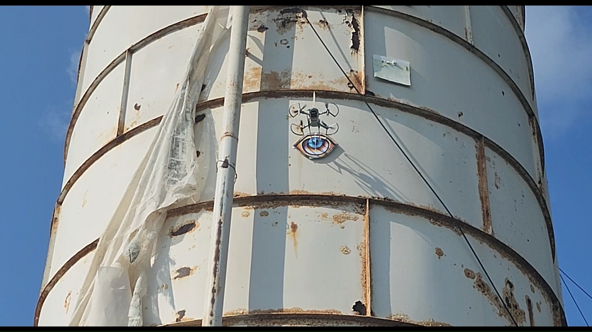

**Troubleshooting**

If the drone doesn't lift or is unstable, use a larger drone or a lighter payload, and make sure you push the engine to full power before releasing the drone. Often the drone can handle far higher weights after liftoff. Also, the drone seem to be more stable when moving (compare to standing).

If the drone is stable at a low altitude but is unstable, probably the wind.

If the plate doesn't stick, try a lower approach angle (lower speed), and more double-side tape, mainly on the plate top, where the drone push.Adding superglue to the back of the plate can help (in general, the double side tape is for immediate attachment, and the other adhesive are for more long-term durable attachment, but some glue can actually do both if you can get the plate to the wall before its dry).

**Drone size**

The smaller the drone, the less it can lift DJI MINI 2 can easily lift A4(20x30) size plate with some wind and A3 (30x40cm) with no wind (around 100-120 gr). The plate increases the drone's surface area and effectively acts as a sail, so you really want to avoid strong winds.